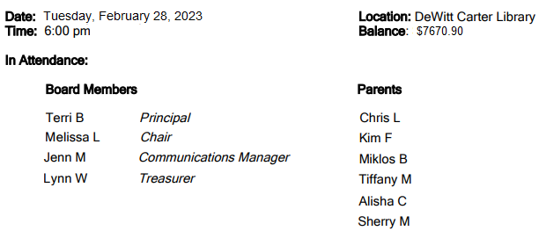
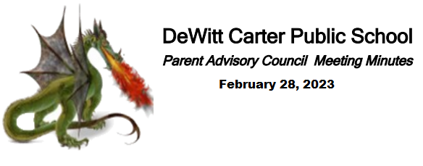

- Welcome- Melissa L. (Chair)

- Administrative Report – Mrs. Beck
  - Assembly Slideshow presented
  - End of School trips have been planned (besides the Kindergarten classes)
    - Primary – bowling, mini golf and pizza
    - Grade 4-6- Overnight camp – Binbrook (paid for by Superintendent)
    - Grade 7-8 – Toronto day – May 30th - $230 (approx) illusions, reptile aquarium, CN tower, spaghetti house, graffiti alley – taken on a coach bus *also a trip to Binbrook (June 27)
  - A meditation room is being created in a side room in the Library- open to all students -with office permission
  - The school is been acknowledging Black History Month (February)
  - EQAO is underway for the Grade 3 and 6 students
  - Vaping issues are being addressed to students. The Tobacco officer has been involved – strong one time warnings

- Finances-
  - $7670.90 – in account
  - Allocated: Outdoor Class, Gym Mats and Graduation
  - $3370.90 if allocated came out
- Introductions: No new members

- Old Business-
  - Krispy Kreme was looked into for a fundraiser – however, they are already booking for July so this school year is out. If wanting to do it in the fall, then we will need to book soon. If doing for next Spring, should be decided in September`s or October`s meeting. Agreed to table this to another meeting.
  - McMillans fundraiser is another fundraiser looked at. Motioned: 1st – Chris, 2nd by Tiff.- Voted: Passed
Will start end of March and run to after Easter and delivery day is May 4th.
  - Niagara Inflatable for Fun Night – Originally came back with a much higher quote than expected. Melissa worked with them- they agreed to work with the total to be closer to our original amount (from 2019)
  - Fun Night Sub Committee- Next meeting scheduled for Wednesday, March 22nd
  - Chocolate Bar BINGO- Melissa retrieved the BINGO game supplies from Oakwood School as well as the chips and water for the participants. All set for Thursday night`s event. Volunteers already signed up and meeting at the school for approx 4pm.

- New Business-
  - Sleds - Request for sleds for the playgrounds $150. – Motioned: 1st Chris 2nd by Lynn – Vote: Passed
  - Pizza/Milk Days – for April and May are being preplanned- Lynn will create a signup sheet and send out
  - PIC Information:
    - PIC money to be used to purchase Popcorn Supplies to replenish from previous events
    - We were approved to have a fully funded “OWL” (a camera that will allow events to be streamed) – to arrive at the school shortly
    - 2023/2024 tentative school schedule did have a change – moved May 2024 PA day to April 8, 2024 due to an astronomical event that will happen.

- Next Meeting scheduled for March 28, 2023 – at 6:00 pm – School Library

